SIMATS ENGINEERING
ASSESSMENT TOOL 1
COURSE NAME: INTERNET PROGRAMMING
COURSE CODE: CSA43
COURSE OUTCOME COVERED
CO-1 : Develop well-structured, standards-compliant web pages using HTML/XHTML and XML, and apply Internet protocols and HTTP communication mechanisms for web content delivery. (L2)
Assessment Tool : Application-Based Questions
Weightage: 40%
QUESTIONS: Total Marks: 30

1: Online Symposium Portal
A college is developing an online symposium registration portal. The following HTML structure and HTTP interaction is observed:
<form action="/register" method="POST">
<input type="text" name="name">
<input type="email" name="email">
<button>Submit</button>
</form>
When a student submits the form, the browser sends an HTTP request to the server, and the server responds accordingly. Questions:
- Identify appropriate HTML5 semantic elements missing in the structure.
- Modify the structure to make it standards-compliant.
- Interpret the HTTP request generated during form submission.
- Analyze the HTTP response cycle from server to browser.
- Suggest improvements for usability and accessibility.

2: Cross-Browser Compatibility Issue
A company website shows inconsistent layout across browsers. The following HTML snippet is used:
<html>
<head>
<title>Company</title>
</head>
<body>
<div>
<h1>Welcome
<p>About us
</div>
</body>
</html>
Questions:
- Identify improper nesting and missing closing tags.
- Analyze how different browsers may interpret this structure.
- Identify missing semantic elements (e.g., header, section).
- Provide a corrected W3C-compliant HTML structure.
- Suggest techniques to ensure cross-browser compatibility.

3: Form Submission Failure
A web application fails to send form data to the server. The following configuration is observed:
<form action="/submit" method="GET">
<input type="text" name="username">
<input type="password" name="password">
<button type="button">Login</button>
</form>
Questions:
- Identify issues in the form configuration.
- Analyze why the HTTP request is not triggered.
- Interpret the role of GET method in this scenario.
- Propose a corrected implementation.
- Suggest improvements for secure data transmission.
Code of Conduct:
I __R.Asif__ (Name / Reg No) certify that this submission is my original work and that I have adhered to the guidelines specified for this assessment. I understand that any violation of academic integrity rules will result in disciplinary action.
Signature of the student:R.Asif
Answers

1. Online Symposium Portal

1.1 Identify appropriate HTML5 semantic elements missing in the structure.
The missing semantic elements are:
- <header> – for the symposium heading.
- <main> – for the main registration content.
- <section> – for grouping registration-related content.
- <footer> – for footer information.
- <label> – for properly describing input fields.
These elements improve structure, accessibility, and readability.

1.2 Modify the structure to make it standards-compliant.
<!DOCTYPE html>
<html lang="en">
<head>
<meta charset="UTF-8">
<meta name="viewport" content="width=device-width, initial-scale=1.0">
<title>Symposium Registration</title>
</head>
<body>

<header>
<h1>College Symposium Registration</h1>
</header>

<main>
<section>
<h2>Student Registration</h2>

<form action="/register" method="POST">
<label for="name">Name:</label>
<input type="text" id="name" name="name" required>

<label for="email">Email:</label>
<input type="email" id="email" name="email" required>

<button type="submit">Submit</button>
</form>
</section>
</main>

<footer>
<p>College Symposium 2026</p>
</footer>

</body>
</html>
This structure uses proper HTML5 elements, labels, validation, and a submit button.

1.3 Interpret the HTTP request generated during form submission.
When the user clicks Submit, the browser sends a POST request to /register.
Example:
POST /register HTTP/1.1
Content-Type: application/x-www-form-urlencoded

name=Asif&email=asif@example.com
The server receives and processes the submitted form data.

1.4 Analyze the HTTP response cycle from server to browser.
The HTTP response cycle is:
User fills form
↓
Browser sends HTTP POST request
↓
Server receives request
↓
Server processes data
↓
Server sends HTTP response
↓
Browser displays result
A successful response may contain status 200 OK and an HTML page showing successful registration.

1.5 Suggest improvements for usability and accessibility.
- Use proper <label> elements.
- Use suitable input types such as email.
- Use required for important fields.
- Provide clear error messages.
- Use meaningful button text.
- Make the page keyboard accessible.
- Use readable text and sufficient color contrast.
- Make the page responsive for mobile devices.
- Use semantic HTML elements.

Screenshorts:
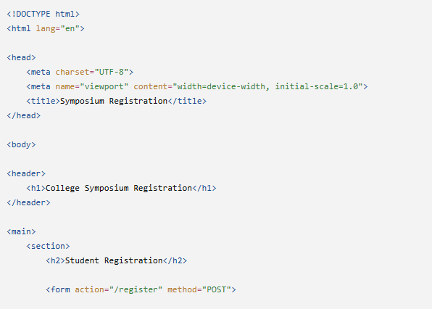
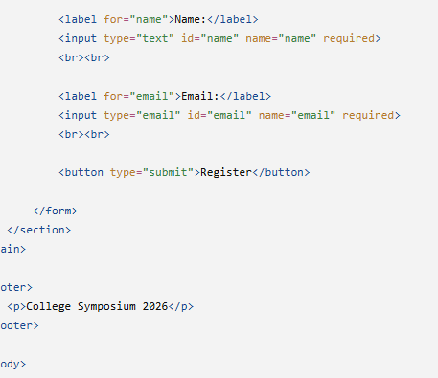
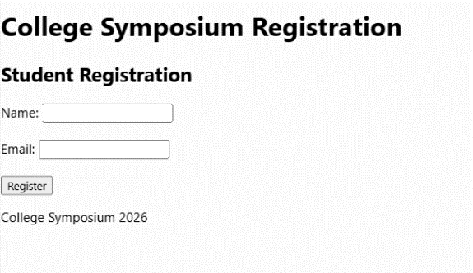

2. Cross-Browser Compatibility Issue

2.1 Identify improper nesting and missing closing tags.
The <h1> and <p> elements are not properly closed.
Incorrect:
<h1>Welcome
<p>About us
Correct:
<h1>Welcome</h1>
<p>About us</p>
The document also needs <!DOCTYPE html> for proper HTML5 standards mode.

2.2 Analyze how different browsers may interpret this structure.
Browsers may automatically try to correct missing closing tags, but the result can differ between browser engines.
This may cause:
- Different layouts.
- Unexpected element nesting.
- CSS problems.
- JavaScript/DOM issues.
- Accessibility problems.
Therefore, valid and properly structured HTML should always be used.

2.3 Identify missing semantic elements.
The webpage should use:
- <header> – for the company heading.
- <main> – for the main content.
- <section> – for the About Us content.
- <footer> – for footer information.
Semantic elements make the webpage easier to understand, maintain, and access.

2.4 Provide a corrected W3C-compliant HTML structure.
<!DOCTYPE html>
<html lang="en">

<head>
<meta charset="UTF-8">
<meta name="viewport" content="width=device-width, initial-scale=1.0">
<title>Company</title>
</head>

<body>

<header>
<h1>Welcome</h1>
</header>

<main>
<section>
<h2>About Us</h2>
<p>About us</p>
</section>
</main>

<footer>
<p>Copyright 2026 Company</p>
</footer>

</body>
</html>
This code follows HTML5 standards and uses proper nesting and semantic elements.

2.5 Suggest techniques to ensure cross-browser compatibility.
- Use valid HTML5 and CSS.
- Include <!DOCTYPE html>.
- Properly close and nest elements.
- Test the website in Chrome, Firefox, Edge, and Safari.
- Use responsive design.
- Avoid browser-specific features.
- Use CSS normalization when required.
- Validate HTML and CSS.
- Use feature detection for advanced features.

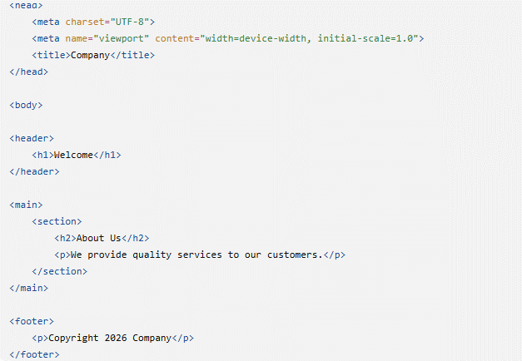
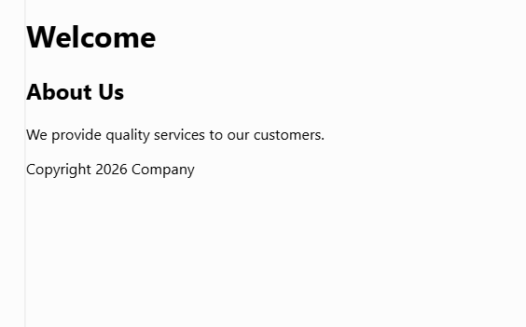

3. Form Submission Failure

3.1 Identify issues in the form configuration.
The main issues are:
- The button uses type="button" instead of type="submit".
- GET is not suitable for sending passwords because the data appears in the URL.
- Labels are missing.
- Input validation such as required is missing.

3.2 Analyze why the HTTP request is not triggered.
The request is not triggered because:
<button type="button">Login</button>
is a normal button and does not submit the form.
It should be:
<button type="submit">Login</button>
Then clicking the button will submit the form.

3.3 Interpret the role of GET method in this scenario.
GET sends form data through the URL as a query string.
For example:
/submit?username=Asif&password=12345
GET is suitable for retrieving information but is not suitable for passwords or sensitive data because the data can appear in browser history, URLs, and server logs.
POST should be used for login forms.

3.4 Propose a corrected implementation.
<!DOCTYPE html>
<html lang="en">

<head>
<meta charset="UTF-8">
<meta name="viewport" content="width=device-width, initial-scale=1.0">
<title>Login</title>
</head>

<body>

<form action="/submit" method="POST">

<label for="username">Username:</label>
<input type="text" id="username" name="username" required>

<label for="password">Password:</label>
<input type="password" id="password" name="password" required>

<button type="submit">Login</button>

</form>

</body>
</html>
The important corrections are POST method, submit button, labels, and required fields.

3.5 Suggest improvements for secure data transmission.
- Use HTTPS to encrypt communication.
- Use POST instead of GET for login information.
- Never put passwords in URLs.
- Validate input on the server.
- Store passwords using secure password hashing.
- Use secure session management.
- Use secure cookies with appropriate security attributes.
- Apply rate limiting to prevent repeated login attacks.
Therefore, HTTPS + POST + server-side validation + secure password storage provides better protection for login data.
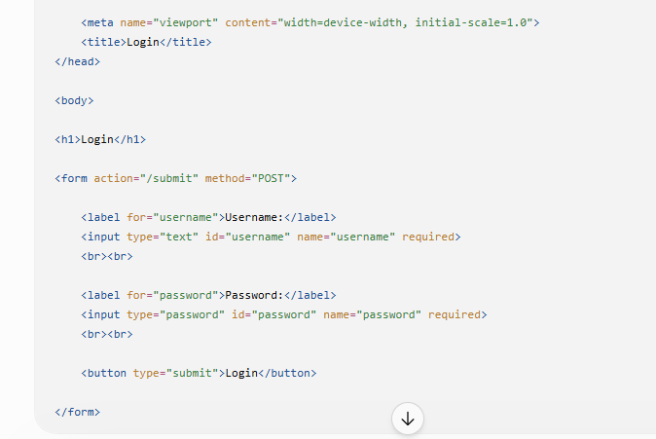
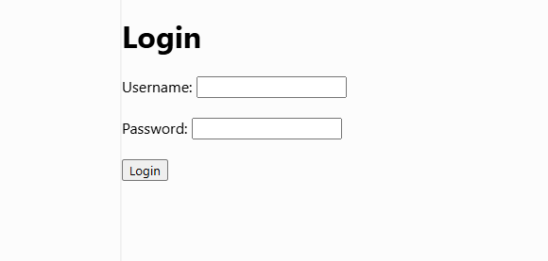

RUBRICS FOR CALCULATION:

Criteria | Weig htage | Level 4 –  Exemplary | Level 3 –  Proficient | Level 2 –  Developing | Level 1 –  Beginning
Understanding of Concepts | 25% | Demonstrates thorough, accurate  understanding of concepts | Good understanding with minor gaps | Basic understanding with some  misconception s | Poor understandin g; major  misconceptio ns
Explanation | 25% | Detailed, wellexplained answers with relevant examples | Clear explanation with adequate  details | Limited explanation; lacks depth | Poor or unclear explanation
Application | 20% | Effectively applies concepts with strong analytical ability | Applies concepts with minor errors | Limited application  with weak analysis | No  application or incorrect analysis
Organization | 15% | Well-structured answers with logical flow and coherence | Organized with minor issues in flow | Basic structure, lacks clarity | Poor organization,  incoherent answers
Accuracy | 10% | Completely accurate and covers all required points | Mostly accurate with minor omissions | Partially correct with missing points | Incorrect answers with major gaps
Clarity | 5% | Clear, neat, professional presentation | Understandable with minor issues | Limited clarity, readability issues | Poorly written,  difficult to understand

